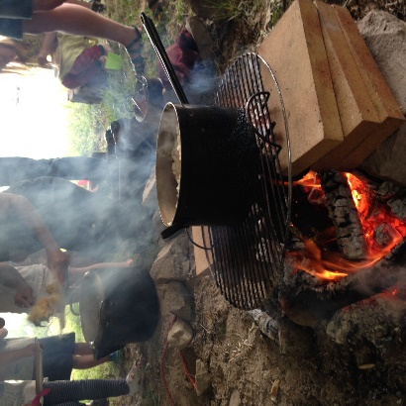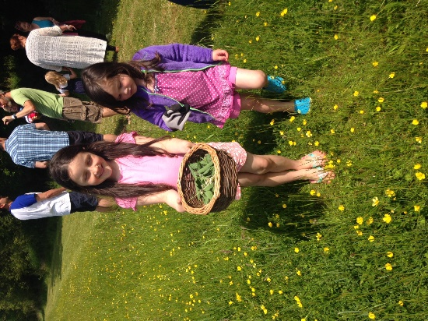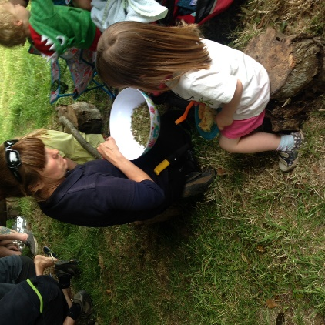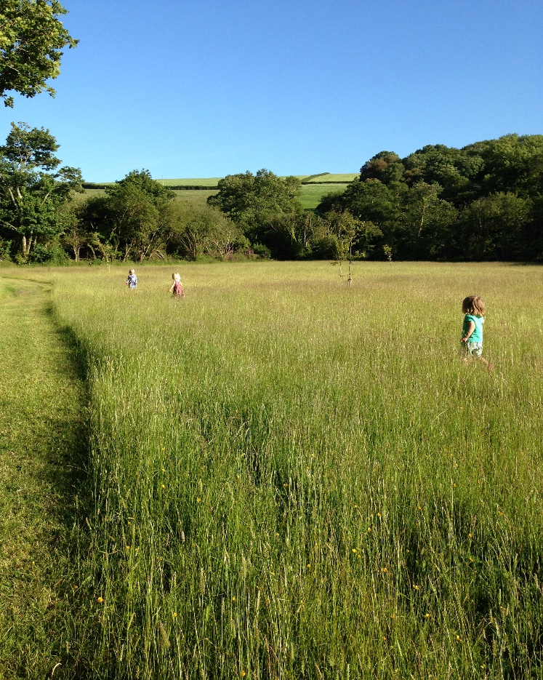

Little Winnick Touring Park,

Pentewan, St Austell

PL26 6DL

www.littlewinnick.co.uk

01726 843687

Family time, making memories together

______

“the best family time I have spent in a long time”

from a dad on June Camp Wild(ish)

______

Wild Camping

______

Wild craft

______

Campfire cooking

______

Camp Craft

______

Den building

______

Qualified Forest School Leaders

______

£60 per family

(based on a family of 4)

Camp Wild(ish) is an opportunity for families to enjoy the outdoors together, with big gaps between each pitch you can make as much noise as you like, but at the same time, enjoy the security of a private camp with camp fire.

**Friday:**

Pitch up, enjoy pasties and hot chocolate around the campfire

**Saturday, 16.00 – 19.00 Sunday, 10.00 – 13.00**

Family Camp Craft Family Camp Craft,

Family Camp Craft sessions are run by qualified Forest School Leaders Sally & Julie and will include wild craft and outdoor fun, campfire cooking (tea on Saturday, lunch on Sunday), making fires, den building, camp games and much more.

In between Camp Craft Sessions, why not wander down to the beach or just relax in the meadow.

Booking essential call or email Heidi

01726 843687 office@littlewinnick.co.uk

Camp Wild(ish)

Friday 22 – Sunday 25 September

Family camping & adventures

Wild camp in our meadow, safe, enclosed -with lovely toilets, showers and bath just a short walk away it is wild camping with a touch of luxury & home comforts.